**LAB 6**

**(Assessment) Logic Check**

**•What is the maximum number of relations that can be true at once in BooleanIf for some a and b input?**

Only **three** is the maximum number of relations can be true at once.

**•What is the minimum number of relations that can be true at once in BooleanIf for some a and b input?**

Only **three** is the minimum number of relations can be true at once.

**•What does Dead code mean?**

**Dead code** is a section in the source **code** of a program which is executed but whose result is never used in any other computation

**•What is the maximum number of output statements showing the relation between a and b for BooleanIfElse?**

O**ne** is the maximum number of outputs showing the relation between a & b.

**•What is the value of a and b where BooleanIfElse will print out “is less than or equal to”?**

The value of **a will be less than b** or alternatively, **a can equal 1 & b can equal 2** making the conditional statement true.

**Activity 3.1.2**

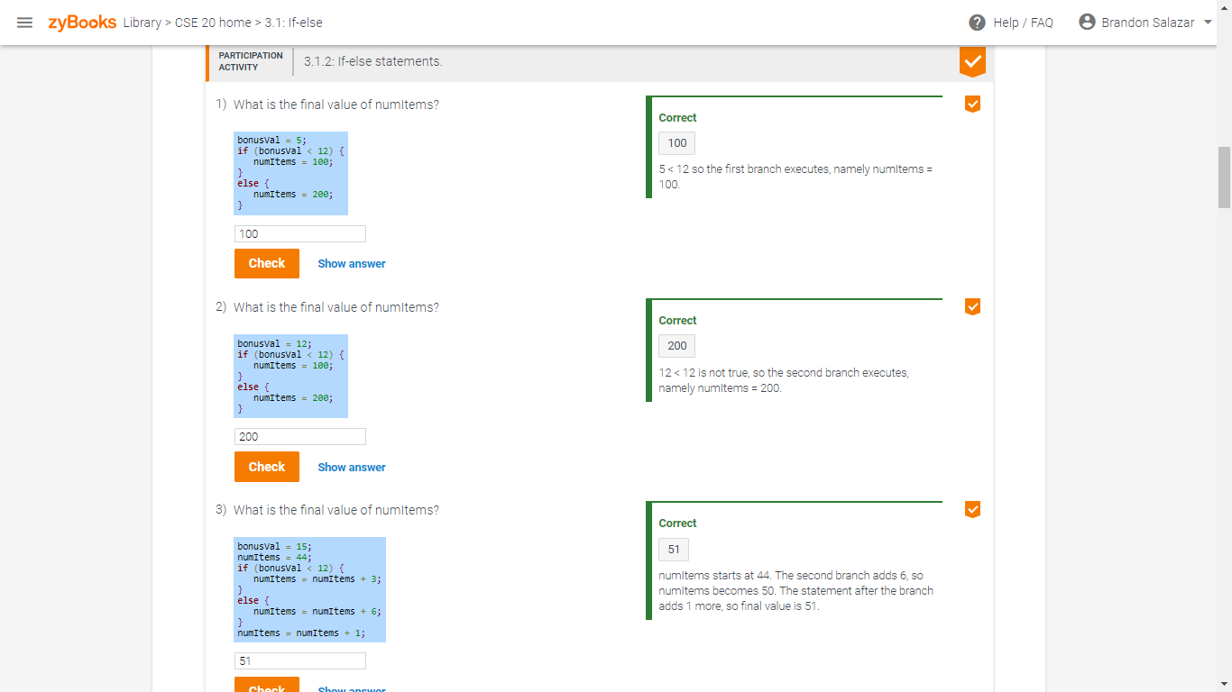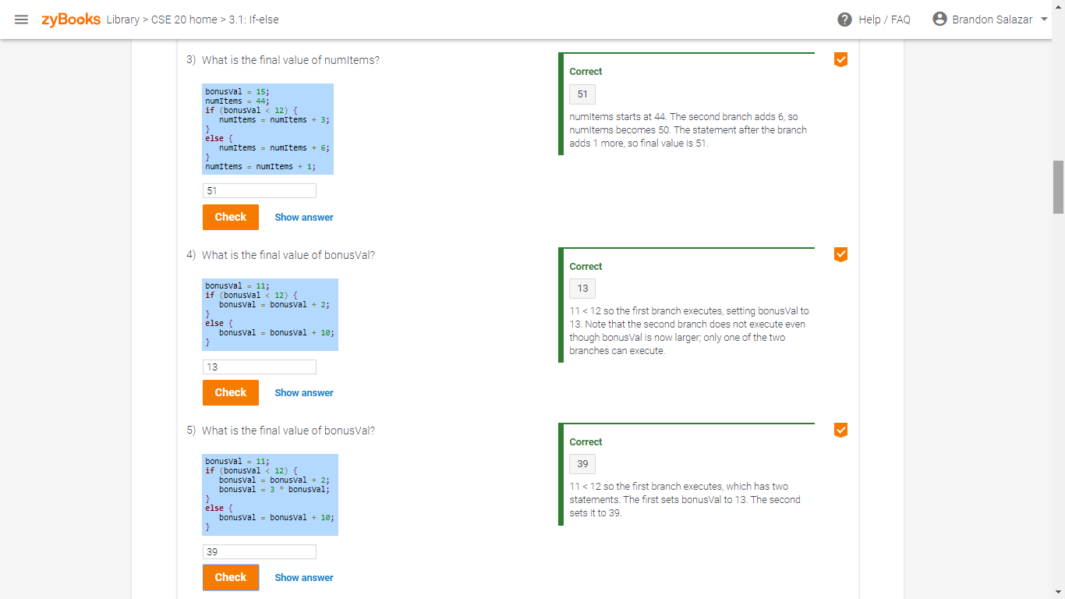

**Activity 3.2.1**

